**DAILY ONLINE ACTIVITIES SUMMARY**

|  |  |  |  |  |  |  |  |  |
| --- | --- | --- | --- | --- | --- | --- | --- | --- |
| **Date:** | **25/06/2020** | | | | | **Name:** | **Syed Hudaif Ibrahim** | |
| **Sem & Sec** | **6th /B** | | | | | **USN:** | **4AL17CS104** | |
| **Online Test Summary** | | | | | | | | |
| **Subject** | | **-** | | | | | | |
| **Max. Marks** | | **-** | | **Score** | | | **-** | |
| **Pre-Placement Training Summary** | | | | | | | | |
| **Pre placement training** | **9:00 am to 11:00 am - JSP**  **11:00 am to 1:00pm - Datastructures in C** | | | | | | | |
| **Faculty** | | | **Mr.Sayeesh**  **Mr.Venkatesh Bhat** | | **Duration** | | | **4 hr** |
| **Assessments** | | | | | | | | |
| 1. **C program to implement simple queue using SLL.** 2. **C program to implement circular queue using SLL.** 3. **C program to implement multiple stack operation using SLL.** 4. **C program to implement operations on multiple queue.** | | | | | | | | |
| **Status: Completed** | | | | | | | | |
| **Uploaded the report in Github** | | | | | **Yes** | | | |
| **If yes Repository name** | | | | | <https://github.com/SyedHudaif/Daily-Reports> | | | |
| **Uploaded the report in slack** | | | | | **Yes** | | | |

**Training snapshots:**

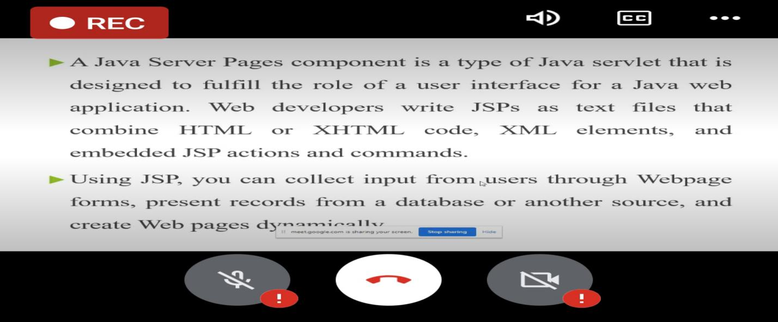

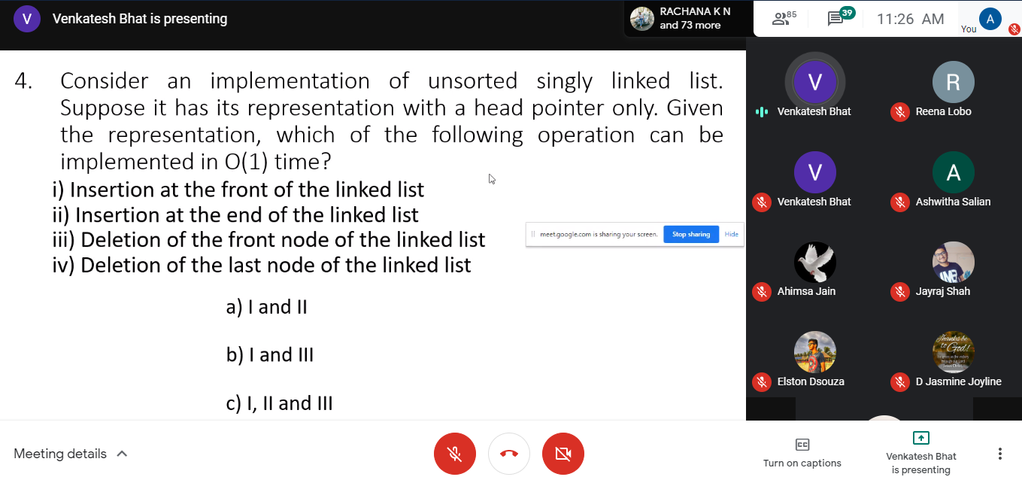

**Assessments:**

**The assessment is uploaded in GitHub repository and the link is given below:**

<https://github.com/SyedHudaif/C-Programming-Wokshop/tree/master/DataStructures>